Dis-Egy-Boat-Cleopatra

From the Egyptian Treasures collection we present

 Cleopatra's Royal Nile Barge with Cleopatra on bed.

69585AA

Made from solid cold cast resin and hand painted. This beautiful figurine measures approx. 5.5''t x 12.75''w x 3.5''d.

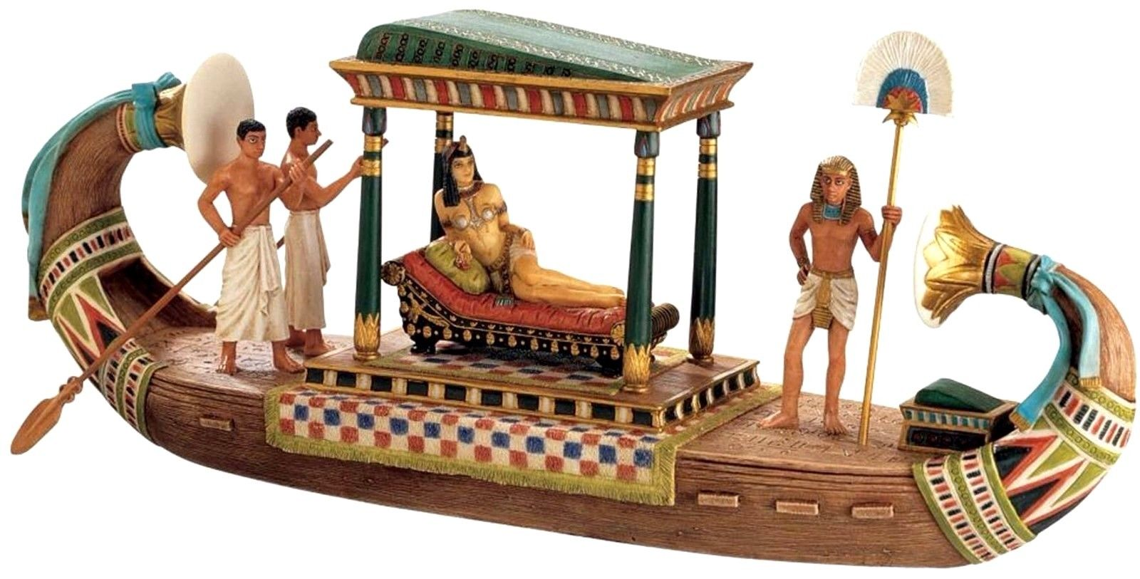 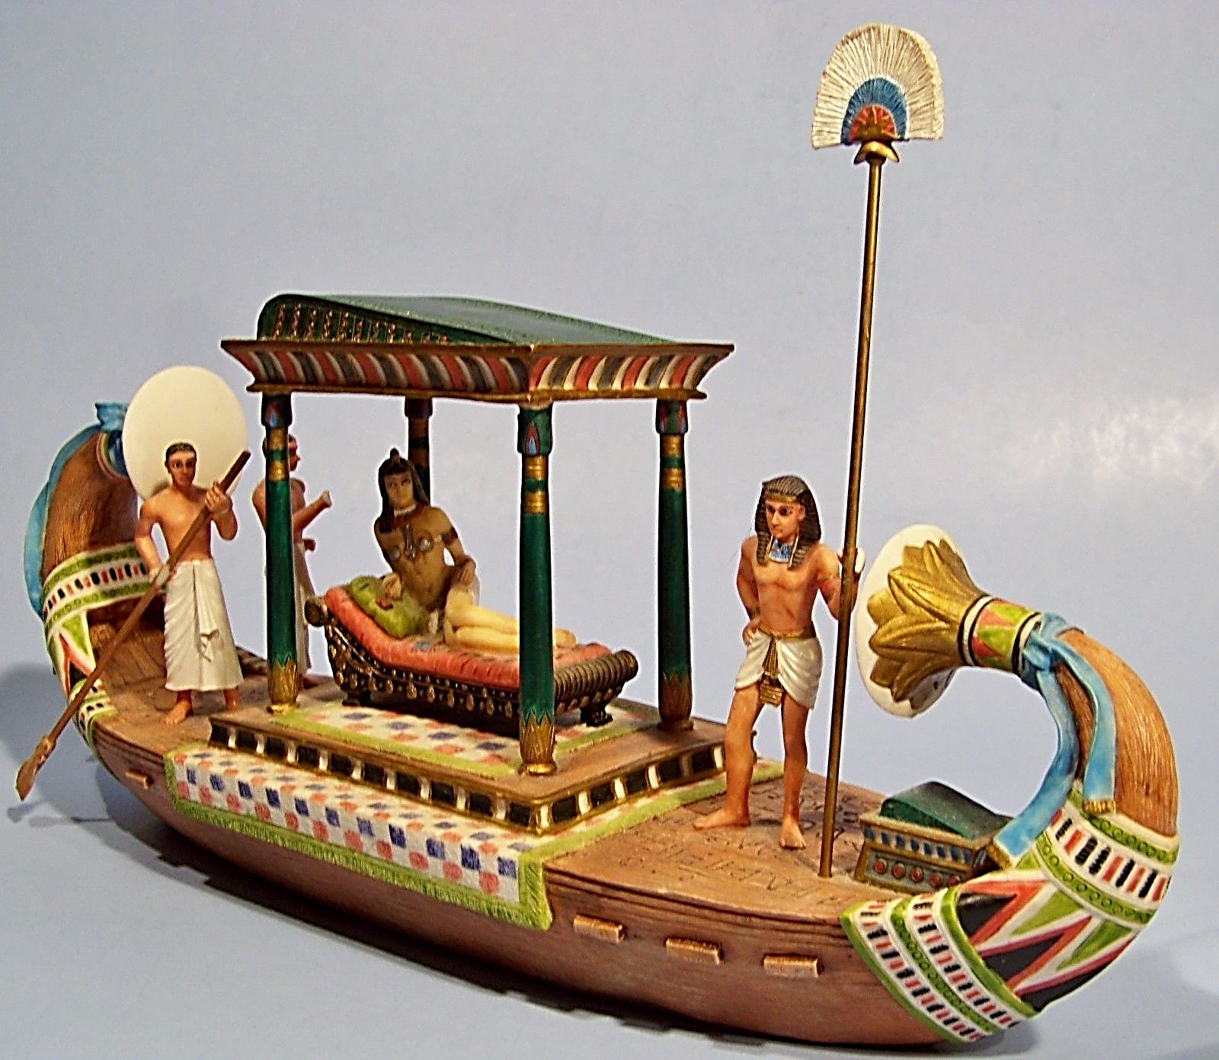 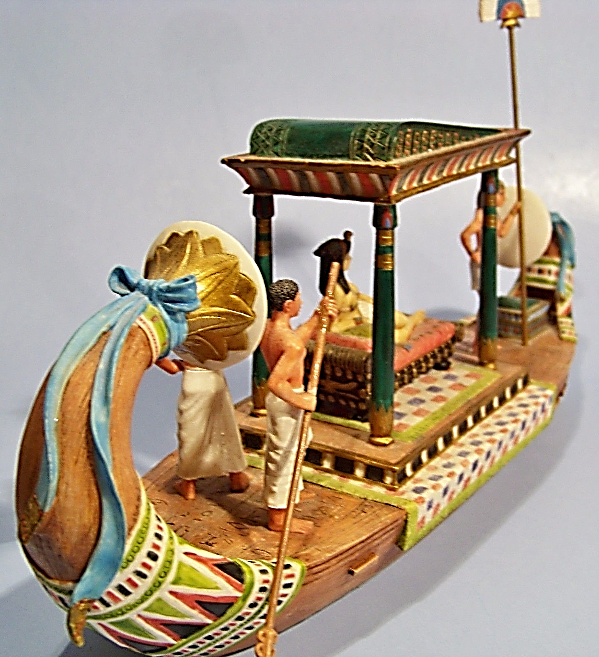

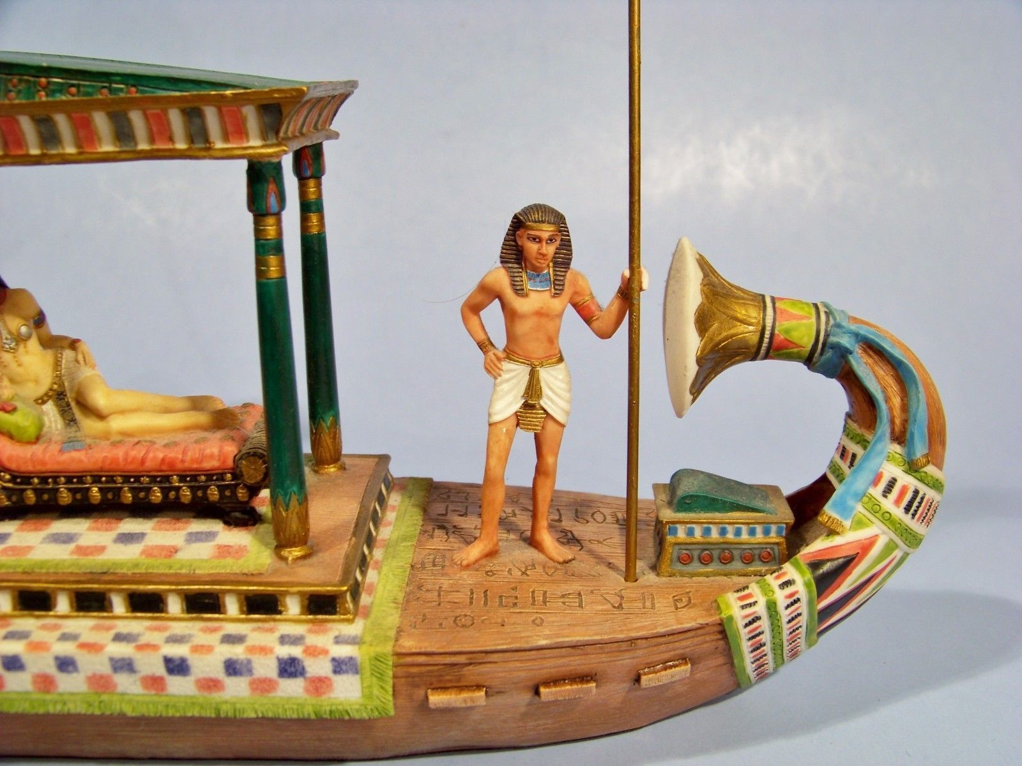

Beautifully detailed hand-painted resin replica depicts Cleopatra reclining on a lounge beneath a multicolored canopy as three servants surround her. The detail is exceptional, from the fringed carpet on the deck to the blue ribbons on the bow and stern.